Day 16 - 11th July- 113195064 - Bondili Bhavya Charitha

TASK:1,2 &3 – Selection Sorting
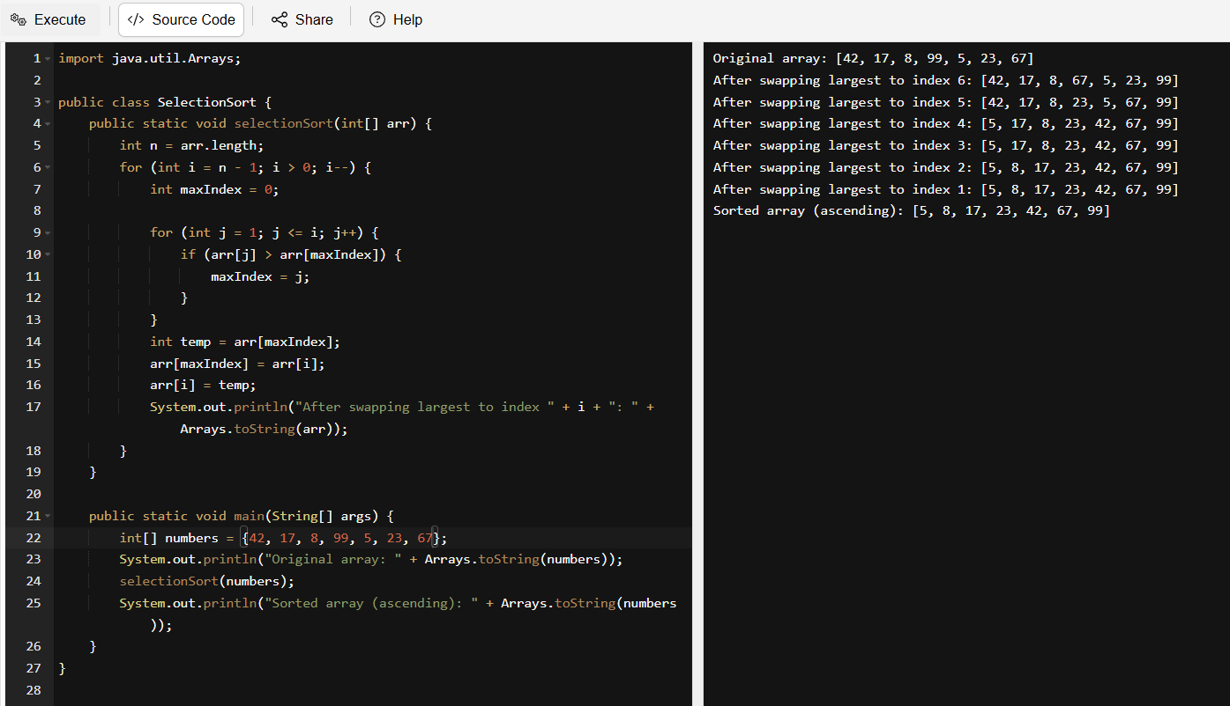
Selection Sort Algorithm:
Input: An array of Integers.
Output: The array sorted in ascending order
Steps:
- Start with the entire array.
- Let n be the length of the array.
- Loop from i = n - 1 down to 1:
- Initialize maxIndex = 0.
- Traverse the unsorted part from index 1 to i:
- If arr[j] > arr[maxIndex], update maxIndex = j.
- Swap arr[maxIndex] with arr[i] (place the largest at end of unsorted section).
- Repeat the process for the next pass (from 0 to i - 1).
- After all passes, the array is sorted in ascending order.
- End
Pseudocode:
procedure selectionSort(arr)
n ← length of arr

for i ← n - 1 down to 1 do
maxIndex ← 0

for j ← 1 to i do
if arr[j] > arr[maxIndex] then
maxIndex ← j
end if
end for
swap arr[maxIndex] and arr[i]
end for
end procedure
Example: Given array is [42, 17, 8, 99, 5, 23, 67]. Pass 1: Largest is 99 → Swap with index 6, Pass 2: Largest in [42, 17, 8, 67, 5, 23] is 67 → Swap with index 5 ... Continue until sorted.

TASK:4,5&6 – Bubble Sorting
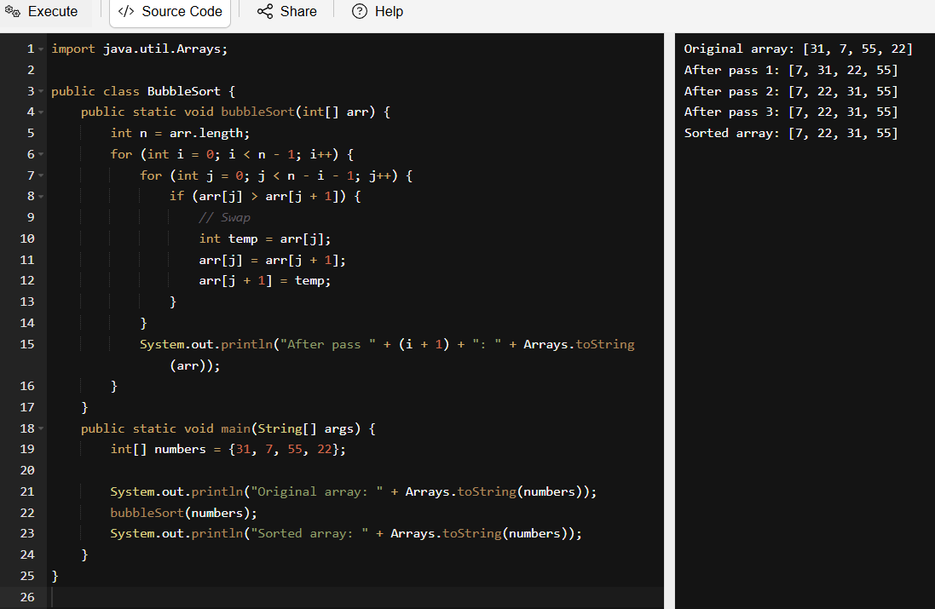
Bubble Sort Algorithm:
Input: An array of Integers.
Output: Sort an array in increasing order by repeatedly swapping adjacent no order elements.
Steps:
- Start with an array arr of size n = 4.
- For each pass from i = 0 to n - 2:
- Traverse the array from index j = 0 to n - i - 2.
- Compare arr[j] and arr[j + 1].
- If arr[j] > arr[j + 1], swap the two elements.
- After each pass, the largest unsorted element "bubbles" to its correct position.
- Repeat the process until all elements are sorted.
- End.

Pseudo Code:
procedure bubbleSort(arr)
n ← length of arr
for i ← 0 to n - 2 do
for j ← 0 to n - i - 2 do
if arr[j] > arr[j + 1] then
swap arr[j] and arr[j + 1]
end if
end for
end for
end procedure
Example Array:
Array: arr = [31, 7, 55, 22]
Pass 1 (i = 0):
Compare 31 and 7 → swap → [7, 31, 55, 22]
Compare 31 and 55 → no swap
Compare 55 and 22 → swap → [7, 31, 22, 55]
Result after pass 1: [7, 31, 22, 55]
Pass 2 (i = 1):
Compare 7 and 31 → no swap
Compare 31 and 22 → swap → [7, 22, 31, 55]
Result after pass 2: [7, 22, 31, 55]
Pass 3 (i = 2):
Compare 7 and 22 → no swap
Result after pass 3: [7, 22, 31, 55] — array is sorted now.
Sorted array: [7, 22, 31, 55].

TASK:7,8 &9 – Insertion Sorting
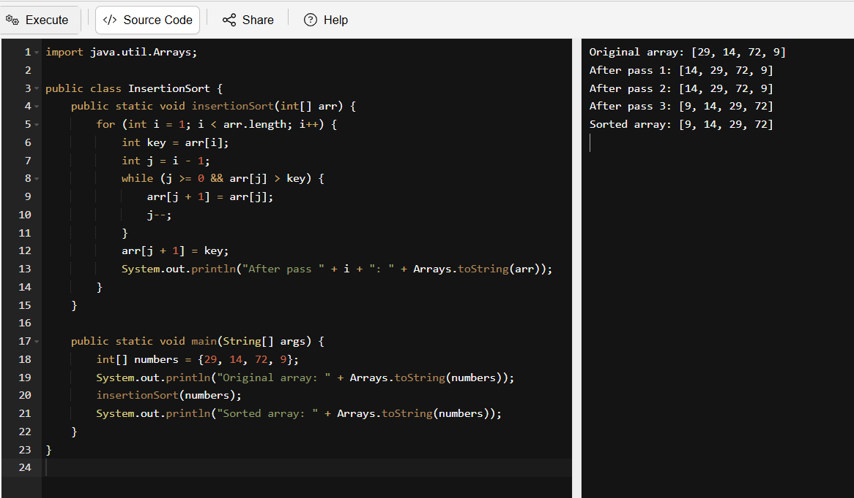
Insertion Sort Algorithm:
Input: An array on integers. Array = {29, 14, 72, 9}.
Output: A sorted array. Array = {9,14,29,72}.
Steps:
- Start from index 1 (second element).
- Let key = arr[i].
- Compare key with all elements before it (arr[j], where j = i - 1).
- If arr[j] > key, shift arr[j] to the right.
- Insert key in its correct position (arr[j + 1]).
- Repeat steps 2–5 for all elements from index 1 to n - 1.
Pseudo Code:
procedure insertionSort(arr)
for i ← 1 to length(arr) - 1 do
key ← arr[i]
j ← i - 1
while j ≥ 0 and arr[j] > key do
arr[j + 1] ← arr[j]
j ← j - 1
end while
arr[j + 1] ← key
end for
end procedure
Example Array:
Array = {29, 14, 72, 9}. We start by comparing 14 with 29, shifting 29 right, and inserting 14 before it. Next, 72 is greater than all sorted elements, so no change is needed. Finally, 9 is compared with 72, 29, and 14 — all are shifted, and 9 is placed at the front.

TASK:10 - What are the advantages and disadvantages of Bubble sort Algo? List them
Advantages:
- Simple to understand as its easy logic and implementation, especially for beginners.
- In-place sorting requires no extra memory, as it swaps within the original array.
- Stable algorithm maintains the relative order of equal elements.
- Good for small datasets as those are reasonably efficient when sorting arrays with few items.
Disadvantages:
- Poor performance on large arrays as its time complexity, making it highly inefficient for big data.
- Too many passes as even if the array is nearly sorted, it performs multiple comparisons and swaps.
- Not adaptive without optimization if the array becomes sorted before finishing.
- Used only for educational purposes and it rarely used in practical systems due to better alternatives like Merge Sort or Quick Sort.
- Inefficient swap operations as it may do more swaps than necessary compared to other sorts like Selection Sort.
TASK:11
This recursive function is calling calc(n) without changing the input, which means it keeps calling itself infinitely. That’s why it leads to stack overflow. I can fix it by reducing n in each recursive call, so it joins toward the base case (n == 0).
For n = 5, it returns 5 + 4 + 3 + 2 + 1 + 0 = 15. The recursive depth decreases each time until it hits the safe base case. No infinite loop, no stack overflow.
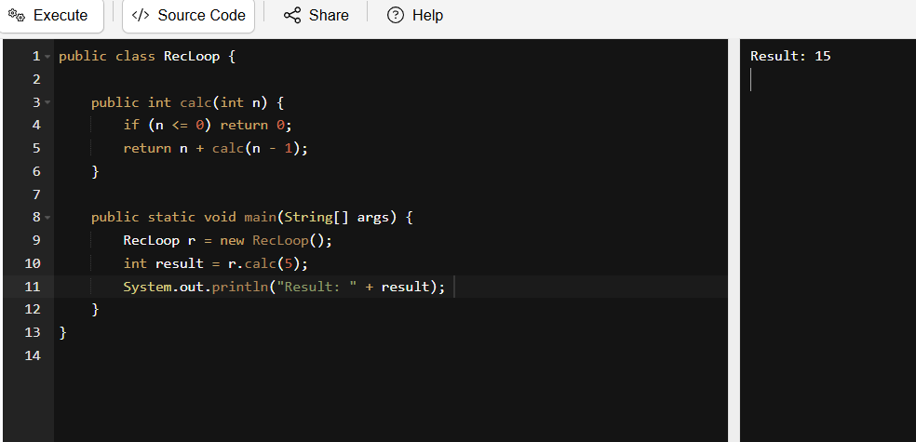

TASK:12, 13&14 – Merge Sorting
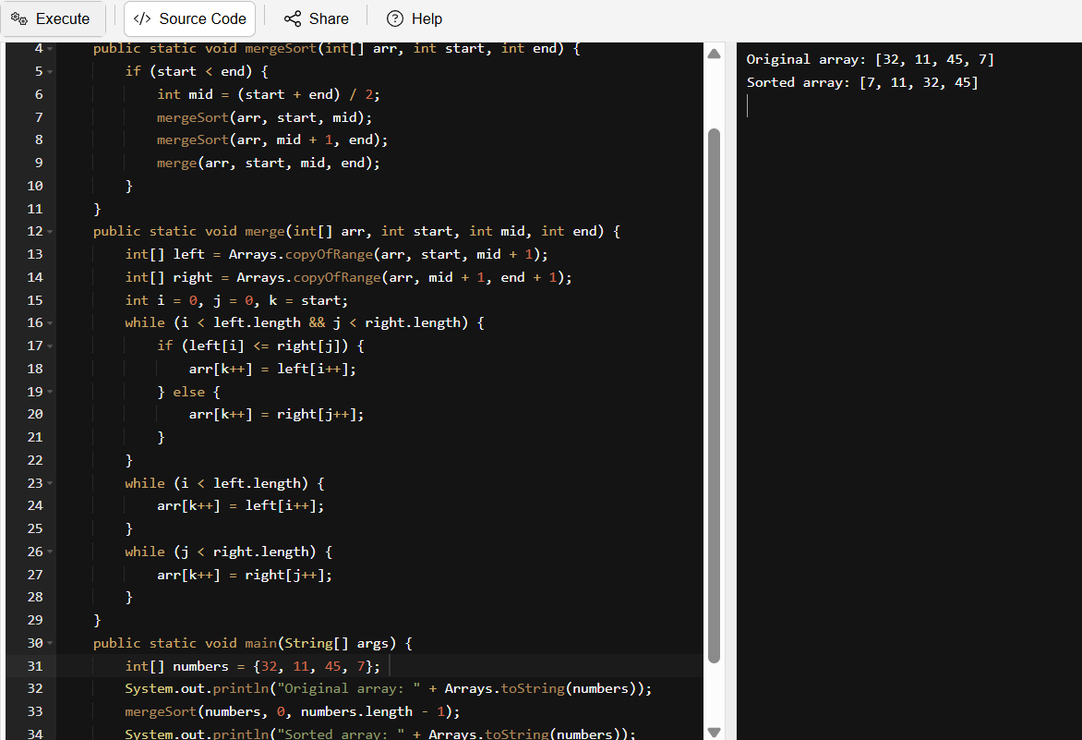

Algorithm:
Input: An array of integers.
Output: Sorted array in ascending order.
Steps:
- Divide the array into two halves recursively until each sub-array has 1 element.
- Merge the sorted halves back together by comparing elements.
- At each merge step, create a new sorted array from the two smaller sorted arrays.
- Continue merging until the full array is sorted.
Pseudocode:
procedure mergeSort(arr, start, end)
if start < end then
mid ← (start + end) / 2
mergeSort(arr, start, mid)
mergeSort(arr, mid + 1, end)
merge(arr, start, mid, end)
end if
end procedure

procedure merge(arr, start, mid, end)
create temp arrays left and right
copy data from arr[start to mid] into left
copy data from arr[mid+1 to end] into right

i ← 0, j ← 0, k ← start
while i < size(left) and j < size(right) do
if left[i] ≤ right[j] then
arr[k] ← left[i]
i ← i + 1
else
arr[k] ← right[j]
j ← j + 1
end if
k ← k + 1
end while

copy remaining elements from left, if any
copy remaining elements from right, if any
end procedure
Example Array:
Divide Phase: The array was split into [32, 11] and [45, 7]
Each half was further split:
[32, 11] → [32], [11]
[45, 7] → [45], [7]
Merge Phase: [32] and [11] were merged into [11, 32]. Comparison: 32 > 11 → 11 goes first
[45] and [7] were merged into [7, 45]. Comparison: 45 > 7 → 7 goes first.
Final Merge: [11, 32] and [7, 45] were merged. Compare: 11 vs 7 → 7 first, then: 11 vs 45 → 11 next then: 32 vs 45 → 32 next then: 45 → last
Final Output: [7, 11, 32, 45].

TASK:15,16 &17 – Quick Sort
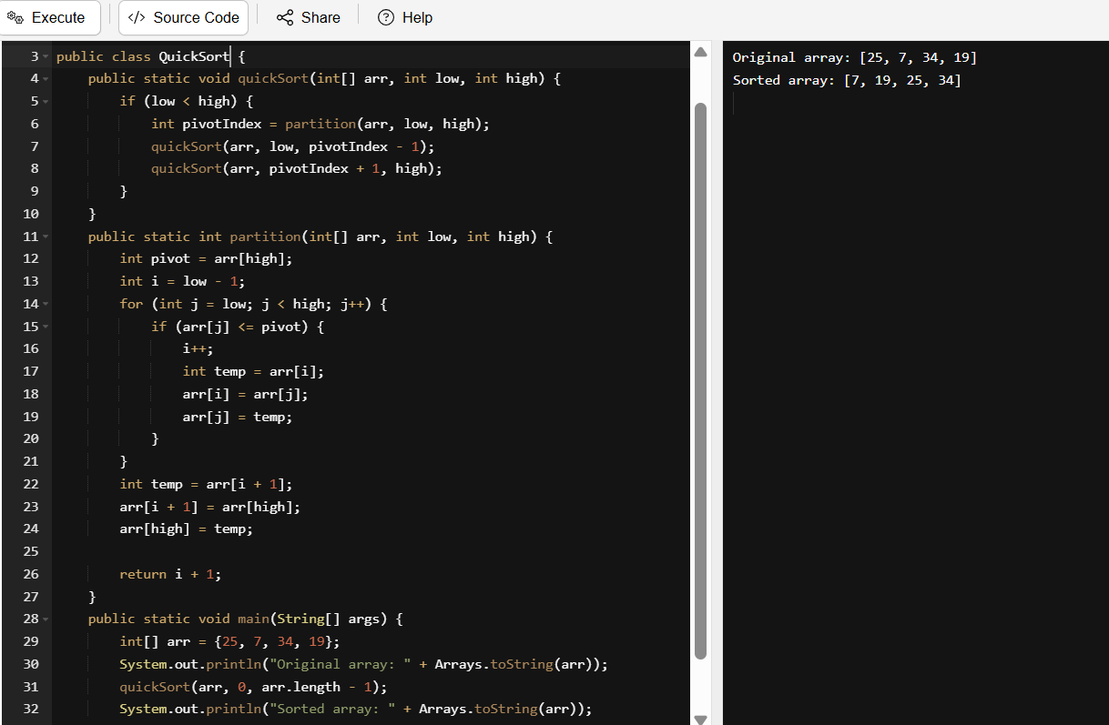
Algorithm:
Input: Array of n elements
Output: sorted array in ascending order
Steps:
- Pick a Pivot: Choose an element (commonly the last one) as the pivot.
- Partition the array:
- Place all elements less than or equal to the pivot on the left, and all greater elements on the right.
- The pivot is now at its correct position.
- Recursively apply steps 1–3 to the left and right subarrays.
- Stop when subarrays have less than or equal to one element.

Pseudo Code:
procedure quickSort(arr, low, high)
if low < high then
pivotIndex ← partition(arr, low, high)
quickSort(arr, low, pivotIndex - 1)
quickSort(arr, pivotIndex + 1, high)
end if
end procedure

procedure partition(arr, low, high)
pivot ← arr[high]
i ← low - 1
for j ← low to high - 1 do
if arr[j] ≤ pivot then
i ← i + 1
swap arr[i] and arr[j]
end if
end for
swap arr[i + 1] and arr[high]
return i + 1
end procedure

Example:
First Call: Range: low = 0, high = 3 → pivot = 19.
Partitioning: compare each element with 19
25 > 19 → no swap
7 < 19 → swap with 25 → [7, 25, 34, 19]
Final pivot swap: place 19 after all smaller values → [7, 19, 34, 25]
Pivot index = 1
Now we will recursively apply Quick Sort to the left [7] and right [34, 25]
Left Subarray: [7]. Already sorted (only one element)
Right Subarray: [34, 25]. Range: low = 2, high = 3 → pivot = 25
Compare: 34 > 25 → no swap
Final pivot swap: swap 25 with 34 → [7, 19, 25, 34]
Pivot index = 2. Both [25] and [34] are now in place.
Final Output: [7, 19, 25, 34].

Add Ons:
- What is the difference between binary tree and binary search tree (bst).
- A binary tree is a hierarchical structure where each node has at most two children: left and right.
- It does not enforce any ordering between nodes.
- A binary search tree (BST) is a special type of binary tree with a strict ordering rule.
- In a BST, the left child contains values less than the parent, and the right child contains values greater than the parent.
- BSTs allow efficient searching, insertion, and deletion — typically in O(log n) time.
- All BSTs are binary trees, but not all binary trees are BSTs.

- In sorted array why do you think binary search tree is best than linear search. Can you explain plz.
- Linear search checks each element one by one, taking O(n) time in the worst case.
- Binary search (used with sorted arrays or BSTs) divides the search space in half each time, taking O(log n) time.
- This makes binary search much faster for large datasets.
- A BST mimics binary search logic structurally, enabling fast lookups, insertions, and deletions.
- So, in a sorted array or BST, binary search is more efficient than linear search.

- Difference between static and dynamic arrays. Plz list them.
- Static arrays have a fixed size defined at creation — they cannot grow or shrink.
- Dynamic arrays can resize automatically as elements are added or removed.
- Static arrays offer faster access and are memory-efficient if size is known.
- Dynamic arrays provide flexibility but may involve costly resizing operations.
- Examples: int arr[10] (static in C), ArrayList in Java or vector in C++ (dynamic).

- In BFS, DFS which one is more preferred in terms of shortest path for the unweighted graphs.
For unweighted graphs, Breadth-First Search (BFS) is preferred for finding the shortest path.

- Write a code to implement a stack using an array. Note: plz ensure bounds are checked to avoid overflow/underflow.
public class Stack {
private static final int MAX_SIZE = 100;
private int[] arr = new int[MAX_SIZE];
private int top = -1;
public void push(int value) {
if (top >= MAX_SIZE - 1) {
System.out.println("Stack Overflow! Cannot push " + value);
return;
}
arr[++top] = value;
System.out.println(value + " pushed to stack.");
}
public void pop() {
if (top < 0) {
System.out.println("Stack Underflow! Cannot pop.");
return;
}
System.out.println(arr[top--] + " popped from stack.");
}
public int peek() {
if (top < 0) {
System.out.println("Stack is empty.");
return -1;
}
return arr[top];
}
public boolean isEmpty() {
return top == -1;
}
public static void main(String[] args) {
Stack s = new Stack();
s.push(10);
s.push(20);
s.push(30);
System.out.println("Top element is: " + s.peek());
s.pop();
s.pop();
s.pop();
s.pop();
}
}
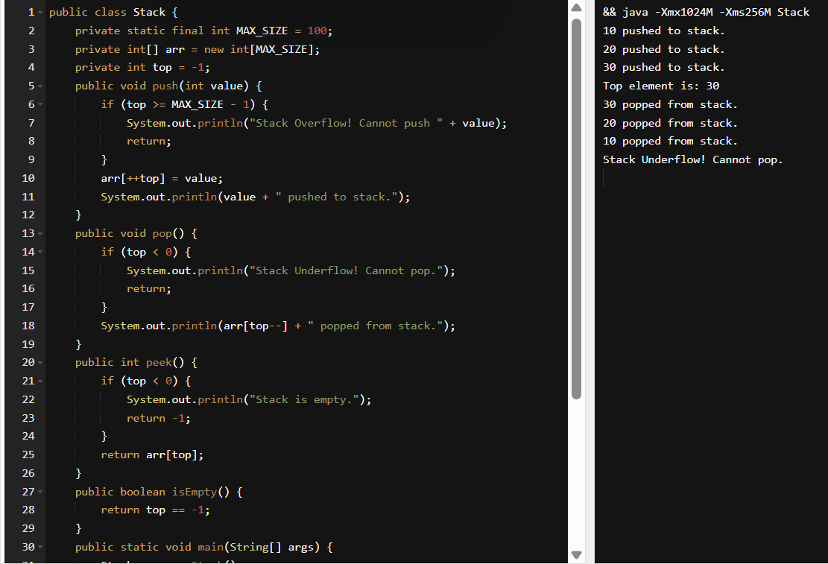
- Home tasks assigned on 4th July and 5th July completed.
- Added 2 new tasks on today.
Write a recursive function to check if a string is a palindrome or not.
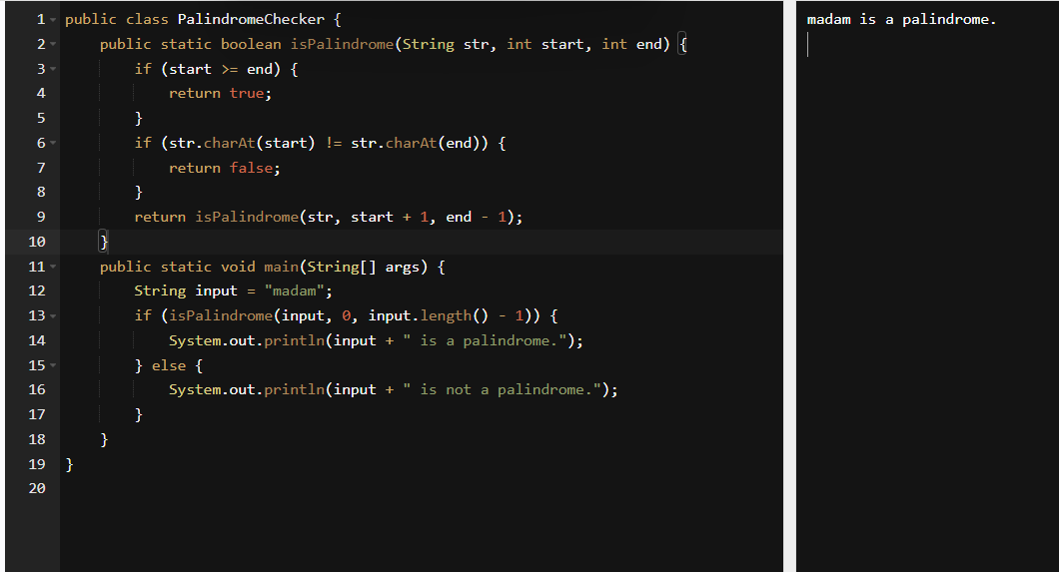
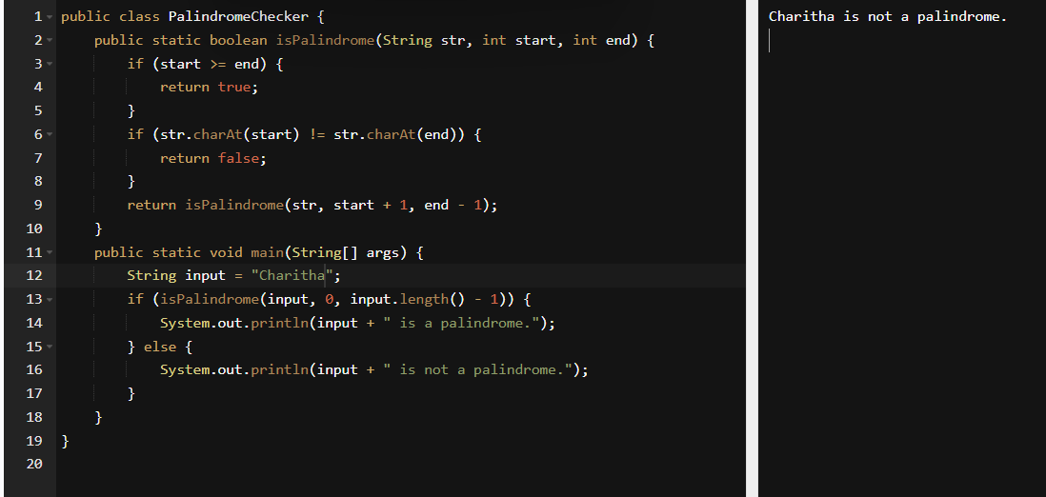

Write a recursive function to copy one array to another.
